Admin@DESKTOP-61APHF9 MINGW64 ~

$ cd d:/jd2_hw

Admin@DESKTOP-61APHF9 MINGW64 /d/jd2_hw (master)

$ git clone https://github.com/DinaMaskalik/jd2_hw.git

Cloning into 'jd2_hw'...

remote: Enumerating objects: 272, done.

remote: Counting objects: 100% (272/272), done.

remote: Compressing objects: 100% (152/152), done.

remote: Total 272 (delta 43), reused 125 (delta 20), pack-reused 0

Receiving objects: 100% (272/272), 7.33 MiB | 2.90 MiB/s, done.

Resolving deltas: 100% (43/43), done.

Admin@DESKTOP-61APHF9 MINGW64 /d/jd2_hw (master)

$ git checkout 11task

Switched to branch '11task'

Your branch is up to date with 'origin/11task'.

Admin@DESKTOP-61APHF9 MINGW64 /d/jd2_hw (11task)

$ git status

On branch 11task

Your branch is up to date with 'origin/11task'.

nothing to commit, working tree clean

Admin@DESKTOP-61APHF9 MINGW64 /d/jd2_hw (11task)

$ git push

Logon failed, use ctrl+c to cancel basic credential prompt.

Everything up-to-date

Admin@DESKTOP-61APHF9 MINGW64 /d/jd2_hw (11task)

$ git checkout master

Switched to branch 'master'

Your branch is up to date with 'origin/master'.

Admin@DESKTOP-61APHF9 MINGW64 /d/jd2_hw (master)

$ git marge 11task

git: 'marge' is not a git command. See 'git --help'.

The most similar command is

merge

Admin@DESKTOP-61APHF9 MINGW64 /d/jd2_hw (master)

$ git merge 11task

Updating 9a9f97c..1db460a

Fast-forward

hw2/task8/src/main/java/it/academy/servlet/NewServlet.java | 1 +

1 file changed, 1 insertion(+)

Admin@DESKTOP-61APHF9 MINGW64 /d/jd2_hw (master)

$ git push

Logon failed, use ctrl+c to cancel basic credential prompt.

Everything up-to-date

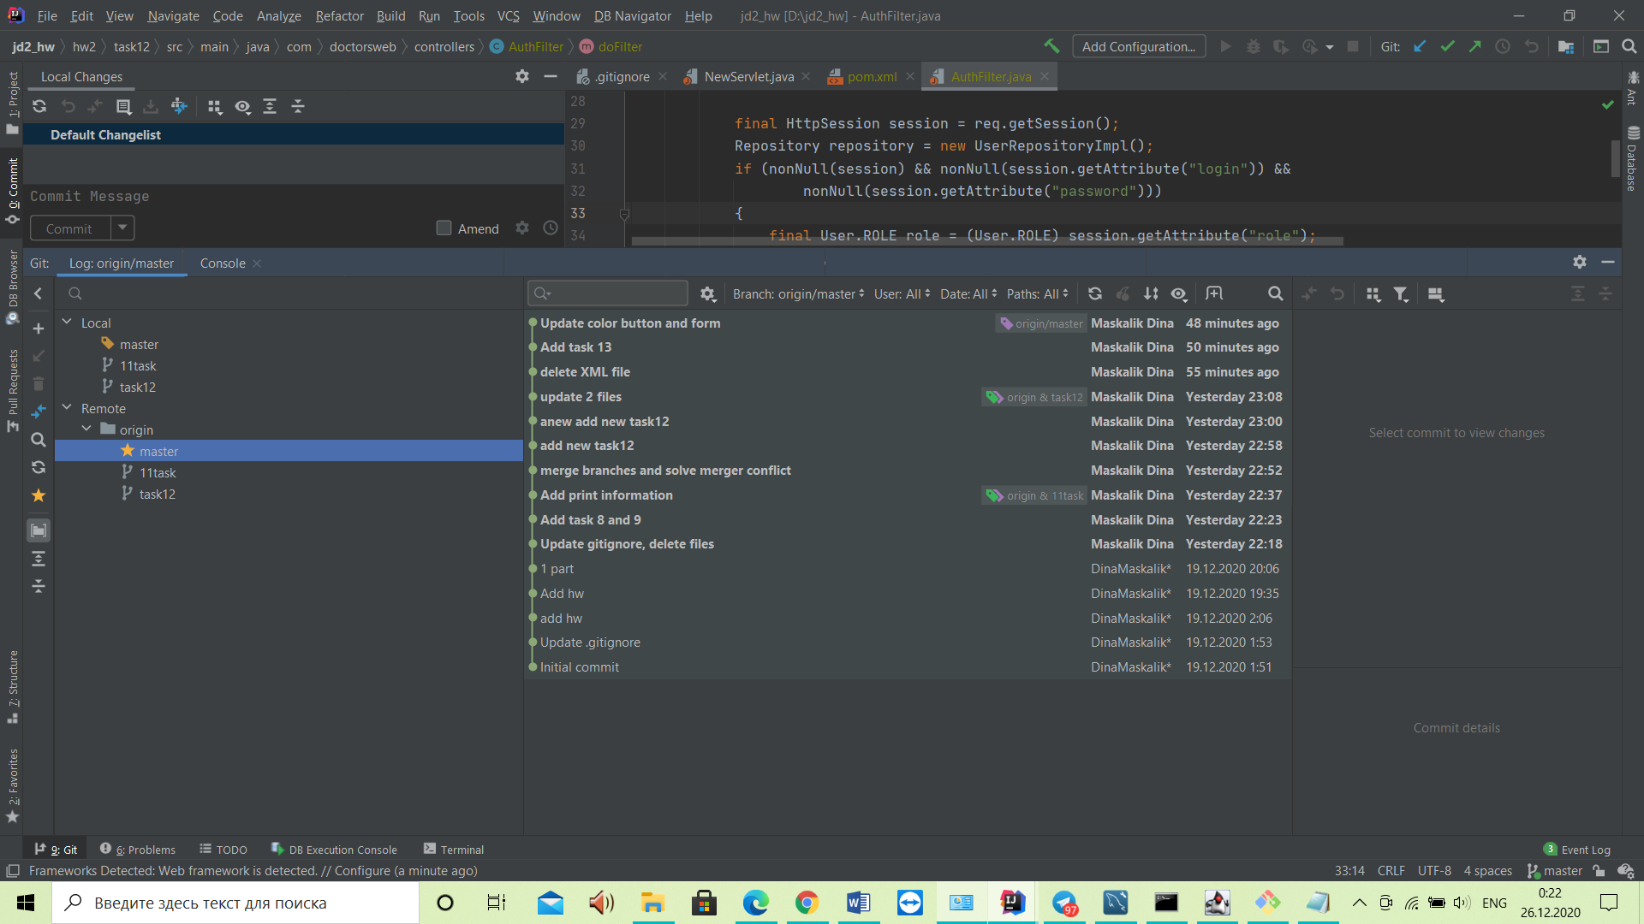

Комиты master

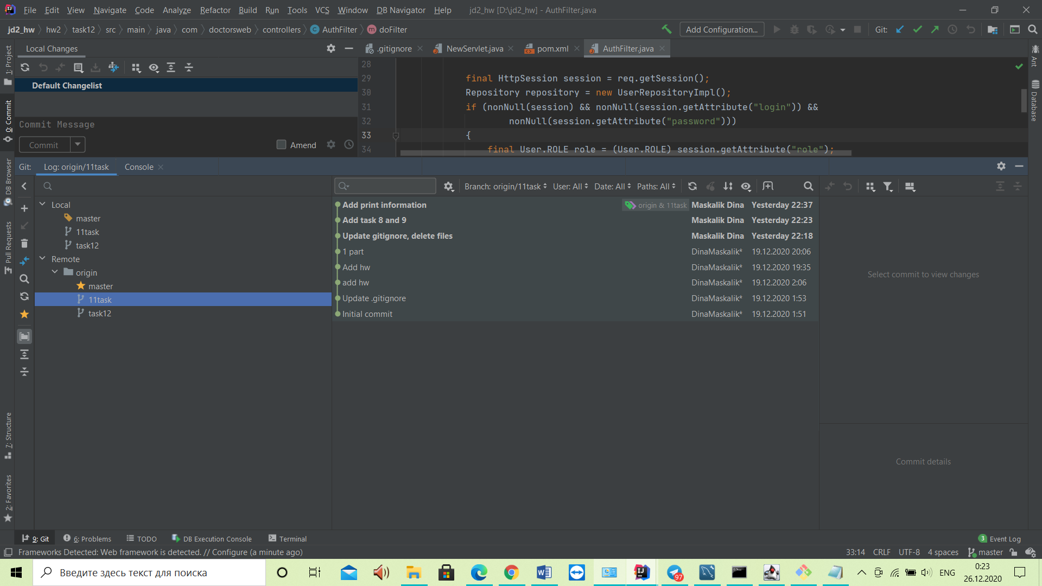

Комиты 11task